$15,000.00
Carpet & Curtain House lot Combo
Average 3 Bedroom House
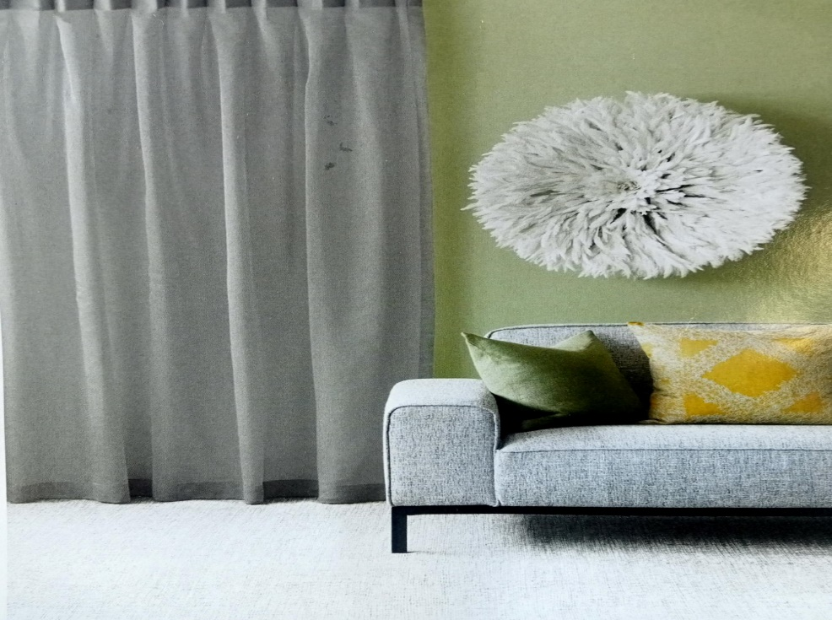
55oz Solution Dyed Nylon or 100% Wool Carpet
Carpet estimate based on Lounge, Dining, Hall, 3 Bedrooms: 75 m2 Floor area, 10mm Underlay, Transition Bars, Smoothedge and Installation.
Avon, Fyf, Oakura, Mackenzie, Piako, Rai, Rakaia, Marlborough Over 50 colours to choose from
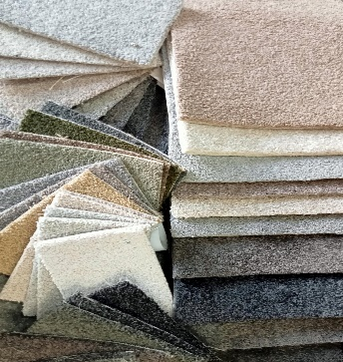
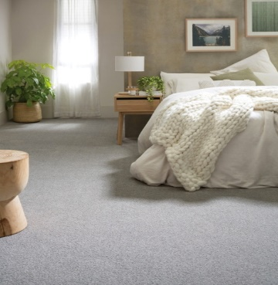

Curtains estimate based on 3 Ranch Sliders, 5 Windows, 1 Roller blind in Kitchen, Curtains and Tracks, Curtain Making and Installation.

